Program Cover Sheet

|  |
| --- |
| Name: Madison Kell |
| Assignment: Assignment 2 |
| List any parts of the assignment that do not work/were not completed:  Validation of the name, I am sure if you have a name like AE-12 that should be fine.  It all works! I am happy with the work I put into this.  Photos: first 4 pages  Code: the rest of the pages |

|  |
| --- |
| Instructor’s Comments: |
| Grade: |

Program Submission Requirements: (1) all files, zipped and uploaded to Canvas and (2) a completed cover sheet, program execution screenshots and source code printed, **stapled** and turned in during class. Failure to follow the submission requirements will result in points lost on that particular assignment.

ORDER FORM CODE

Imports System.ComponentModel

'------------------------------------------------------------

'- File Name : frmOrderFrom.vb -

'- Part of Project: Assignment2 -

'------------------------------------------------------------

'- Written By: Madison Kell -

'- Written On: January 21, 2022 -

'------------------------------------------------------------

'- File Purpose: -

'- This file contains the main application form where the -

'- user will input several features that pertain to a -

'- custom car order. -

'------------------------------------------------------------

'- Program Purpose: - -

'- This program will ask the user will ask to enter features-

'- such as engine type, car type, customer name, quantity, -

'- and up to 9 custom features. All of the features have -

'- different costs and the program will automatically -

'- calculate all of the totals and information and show the -

'- invoice with all of the customs in a different form. From-

'- the invoice form, the user is allowed to change the -

'- original order, sumbit to manufacturing, or exit the -

'- program all together. -

'------------------------------------------------------------

'- Global Variable Dictionary (alphabetically): -

'- None –

'------------------------------------------------------------

Public Class frmOrderForm

Private Sub btnOrder_Click(sender As Object, e As EventArgs) Handles btnOrder.Click

'------------------------------------------------------------

'- Subprogram Name: btnOrder_Click -

'------------------------------------------------------------

'- Written By: Madison Kell -

'- Written On: January 21, 2022 -

'------------------------------------------------------------

'- Subprogram Purpose: -

'- -

'- This subroutine is called whenever the user clicks the -

'- order button. Once this button is clicked, all fields –

'- data wil be entered into a list on the invoice form. -

'- If the user fails to enter one of the designated fields, -

'- they will receive an error message and not be able to -

'- move onto the exit screen. This button also calculates -

'- totals from all individulal fields and displays them at -

'- during the time the invoice screen is called (when this -

'- button is clicked). -

'------------------------------------------------------------

'- Parameter Dictionary (in parameter order): -

'- sender – Identifies which particular control raised the –

'- click event -

'- e – Holds the EventArgs object sent to the routine -

'------------------------------------------------------------

'- Local Variable Dictionary (alphabetically): -

'- (None)

' dblInitalPrice- holds value for inital car price only -

'- dblGrandTotal- holds value for grand total with -

'- all features -

'- dblTotalCarPrice- The total price for quantity and the -

'- inital car price -

'- dblTotalDrive- holds the value of the engine -

'- intCount- holds how many features were selected -

'- intTotalFeature- holds the price for all features -

' selected -

'- strDriveName- the name of the selected car -

'------------------------------------------------------------

frmInvoice.Show() 'showing the invoice screen once the button is clicked

Me.Hide() 'hiding the order screen

Dim dblGrandTotal As Double ' holds value for inital car price only

Dim intCount As Integer = 0 'holds how many features were selected

Dim dblTotalDrive As Double 'holds the value of the engine

Dim strDriveName As String 'the name of the selected car

Dim dblInitialPrice As Double 'holds value for inital car price only

Dim dblTotalCarPrice As Double 'The total price for quantity and the inital car price

Dim intTotalFeature As Integer 'holds the price for all features selected

'if the user forgets to enter a name

If txtName.Text.Length = 0 Then

Me.Show() 'continue to show the order

frmInvoice.Hide() 'hide the invoice

MessageBox.Show("Please enter a name.", "Error: Missing information") 'show an error message

End If

'if the invoice screen has anything in it when the error happens

If frmInvoice.lstInvoice.Items.Count > 1 Then

frmInvoice.lstInvoice.Items.Clear() 'clear the list

End If

'if the user does not select a quantity

If updQuantity.Value < 1 Then

Me.Show() 'continue to show the order

frmInvoice.Hide() 'hide the invoice

MessageBox.Show("Please enter the quantity.", "Error: Missing information") 'show an error message

End If

'if the invoice screen has anything in it when the error happens

If frmInvoice.lstInvoice.Items.Count > 1 Then

frmInvoice.lstInvoice.Items.Clear() 'clear the list

End If

'this if else statement is for the engine.

'if a certain engine is selected, add that amount to the variable

'totalDrive, and set the drive name to the radio button selected

If rdbV12.Checked = True Then

dblTotalDrive = 7500 'how much the v12 costs

strDriveName = "V12" 'set the name to v12

ElseIf rdbV8.Checked = True Then

dblTotalDrive = 2500 'how much the v8 costs

strDriveName = "V8" 'set the name to v8

ElseIf rdbV6.Checked = True Then

dblTotalDrive = 1000 'how much the v6 costs

strDriveName = "V6" 'set the name to v6

ElseIf rdbV4.Checked = True Then

dblTotalDrive = 400 'how much the v4 costs

strDriveName = "V4" 'set the name to v4

ElseIf rdbHybrid.Checked = True Then

dblTotalDrive = 3000 'how much the hybrid costs

strDriveName = "Hybrid" 'set the name to hybrid

ElseIf rdbElectric.Checked = True Then

dblTotalDrive = 6000 'how much the electric costs

strDriveName = "Electric" 'set the name to electric

Else

frmInvoice.Hide() 'if user forgets to select one, hide the invoice

Me.Show() 'continue to show the order screen

MessageBox.Show("Please Select A Drive Train.", "Error: Missing information") 'show an error message

End If

'if the invoice screen has anything in it when the error happens

If frmInvoice.lstInvoice.Items.Count > 1 Then

frmInvoice.lstInvoice.Items.Clear() 'clear the list

End If

'this if else statement is for the type of car.

'if a certain car is selected, add that amount to the variable

'initialPrice, and set the totalCarPrice to the product of the quantity and the initial price

If updCarName.SelectedItem = "Coupe" Then

dblInitialPrice = 10000 'how much the coupe costs

dblTotalCarPrice = updQuantity.Value * dblInitialPrice

ElseIf updCarName.SelectedItem = "Luxury" Then

dblInitialPrice = 20000 'how much the luxury costs

dblTotalCarPrice = updQuantity.Value * dblInitialPrice

ElseIf updCarName.SelectedItem = "Sedan" Then

dblInitialPrice = 17000 'how much the sedan costs

dblTotalCarPrice = updQuantity.Value * dblInitialPrice

ElseIf updCarName.SelectedItem = "Sports Edition" Then

dblInitialPrice = 25000 'how much the sports edition costs

dblTotalCarPrice = updQuantity.Value * dblInitialPrice

ElseIf updCarName.SelectedItem = "SUV" Then

dblInitialPrice = 27000 'how much the suv costs

dblTotalCarPrice = updQuantity.Value * dblInitialPrice

Else

frmInvoice.Hide() 'if user forgets to select one, hide the invoice

Me.Show() 'continue to show the order screen

MessageBox.Show("Please select a car.", "Error: Missing information") 'show an error message

End If

'if the invoice screen has anything in it when the error happens

If frmInvoice.lstInvoice.Items.Count > 1 Then

frmInvoice.lstInvoice.Items.Clear() 'clear the list

End If

'Here is just adding fun and cute stuff to the invoice form

frmInvoice.lstInvoice.Items.Add("=======================================================================")

frmInvoice.lstInvoice.Items.Add(" Kustom Karz Order ")

frmInvoice.lstInvoice.Items.Add("=======================================================================")

frmInvoice.lstInvoice.Items.Add("") 'adding a blank line for spacing

frmInvoice.lstInvoice.Items.Add("Getting ready to kustom manufacture for " & txtName.Text) 'inserting the name on the order

frmInvoice.lstInvoice.Items.Add("") 'adding a blank line for spacing

frmInvoice.lstInvoice.Items.Add("There will be " & updQuantity.Value & " car(s) kustom built") 'inserting the numeber of cars in the fleet

frmInvoice.lstInvoice.Items.Add("") 'adding a blank line for spacing

frmInvoice.lstInvoice.Items.Add("Kar form factor : " & updCarName.SelectedItem & " at " & FormatCurrency(dblInitialPrice)) 'inserting the car name and the price of that car

frmInvoice.lstInvoice.Items.Add("Drive Train Selected: " & strDriveName & " at " & FormatCurrency(dblTotalDrive)) 'inserting the engine selected and the the price of the engine

frmInvoice.lstInvoice.Items.Add("") 'adding a blank line for spacing

frmInvoice.lstInvoice.Items.Add("Here are the options requested: ") 'after this line the features selected will be listed

'if this check box is checked

If chkAC.Checked = True Then

intTotalFeature += 750 'add $750 to the totalFeature

intCount = intCount + 1 'update the number of features added

frmInvoice.lstInvoice.Items.Add(vbTab & "Air Conditioning") 'add the name of the feature to the list

Else

frmInvoice.lstInvoice.Items.Remove(vbTab & "Air Conditioning")

End If

'if this check box is checked

If chkBluetooth.Checked = True Then

intTotalFeature += 750 'add $750 to the totalFeature

intCount = intCount + 1 'update the number of features added

frmInvoice.lstInvoice.Items.Add(vbTab & "Bluetooth") 'add the name of the feature to the list

Else

frmInvoice.lstInvoice.Items.Remove(vbTab & "Bluetooth")

End If

'if this check box is checked

If chkCD.Checked = True Then

intTotalFeature += 750 'add $750 to the totalFeature

intCount = intCount + 1 'update the number of features added

frmInvoice.lstInvoice.Items.Add(vbTab & "CD/MP3 Connections") 'add the name of the feature to the list

Else

frmInvoice.lstInvoice.Items.Remove(vbTab & "CD/MP3 Connections") 'if it is checked and then unchecked, remove it from the list

End If

'if this check box is checked

If chkDefrost.Checked = True Then

intTotalFeature += 750 'add $750 to the totalFeature

intCount = intCount + 1 'update the number of features added

frmInvoice.lstInvoice.Items.Add(vbTab & "Rear Defroster") 'add the name of the feature to the list

Else

frmInvoice.lstInvoice.Items.Remove(vbTab & "Rear Defroster") 'if it is checked and then unchecked, remove it from the list

End If

'if this check box is checked

If chkEntertainment.Checked = True Then

intTotalFeature += 750 'add $750 to the totalFeature

intCount = intCount + 1 'update the number of features added

frmInvoice.lstInvoice.Items.Add(vbTab & "Entertainment Package") 'add the name of the feature to the list

Else

frmInvoice.lstInvoice.Items.Remove(vbTab & "Entertainment Package") 'if it is checked and then unchecked, remove it from the list

End If

'if this check box is checked

If chkGPS.Checked = True Then

intTotalFeature += 750 'add $750 to the totalFeature

intCount = intCount + 1 'update the number of features added

frmInvoice.lstInvoice.Items.Add(vbTab & "GPS") 'add the name of the feature to the list

Else

frmInvoice.lstInvoice.Items.Remove(vbTab & "GPS") 'if it is checked and then unchecked, remove it from the list

End If

'if this check box is checked

If chkHeatedSeats.Checked = True Then

intTotalFeature += 750 'add $750 to the totalFeature

intCount = intCount + 1 'update the number of features added

frmInvoice.lstInvoice.Items.Add(vbTab & "Heated Seats") 'add the name of the feature to the list

Else

frmInvoice.lstInvoice.Items.Remove(vbTab & "Heated Seats") 'if it is checked and then unchecked, remove it from the list

End If

'if this check box is checked

If chkLeatherSeats.Checked = True Then

intTotalFeature += 750 'add $750 to the totalFeature

intCount = intCount + 1 'update the number of features added

frmInvoice.lstInvoice.Items.Add(vbTab & "Leather Seats") 'add the name of the feature to the list

Else

frmInvoice.lstInvoice.Items.Remove(vbTab & "Leather Seats") 'if it is checked and then unchecked, remove it from the list

End If

'if this check box is checked

If chkStereo.Checked = True Then

intTotalFeature += 750 'add $750 to the totalFeature

intCount = intCount + 1 'update the number of features added

frmInvoice.lstInvoice.Items.Add(vbTab & "Premium Stereo") 'add the name of the feature to the list

Else

frmInvoice.lstInvoice.Items.Remove(vbTab & "Premium Stereo") 'if it is checked and then unchecked, remove it from the list

End If

'BY PRINTING OUT I MEAN ADD TO THE LIST

'Add the total car price, total engine price, and total feature price to the grandtotal

dblGrandTotal = dblTotalCarPrice + dblTotalDrive + intTotalFeature

frmInvoice.lstInvoice.Items.Add(intCount & " Options selected for a total of " & FormatCurrency(intTotalFeature)) 'print out the count of features as well as the price for them

frmInvoice.lstInvoice.Items.Add("") 'adding a blank line for spacing

frmInvoice.lstInvoice.Items.Add("Per vehicle total: " & vbTab & vbTab & FormatCurrency(dblInitialPrice + intTotalFeature + dblTotalDrive)) 'price per vehicle with all of the bells and whistles

frmInvoice.lstInvoice.Items.Add("------------------------------------------------------------------") 'fun formatting

frmInvoice.lstInvoice.Items.Add("Quantity Ordered: " & vbTab & vbTab & updQuantity.Value) 'printing the quantity of cars ordered

frmInvoice.lstInvoice.Items.Add("------------------------------------------------------------------") 'fun formatting

frmInvoice.lstInvoice.Items.Add("Grand total: " & vbTab & vbTab & FormatCurrency(dblGrandTotal)) 'printing the grand total with tge quantity

frmInvoice.lstInvoice.Items.Add("==========================================================================================") 'fun formatting

End Sub

Private Sub frmOrderForm_Closing(sender As Object, e As CancelEventArgs) Handles Me.Closing

'------------------------------------------------------------

'- Subprogram Name: frmOrderForm_Closing -

'------------------------------------------------------------

'- Written By: Madison Kell -

'- Written On: January 21, 2022 -

'------------------------------------------------------------

'- Subprogram Purpose: -

'- -

'- This subroutine is called whenever the user clicks the -

'- red x button. The program throw a message to the user –

'- and inform them that they cannot exit the program from -

'- the order form screen and they must continue the order. -

'------------------------------------------------------------

'- Parameter Dictionary (in parameter order): -

'- sender – Identifies which particular control raised the –

'- click event -

'- e – Holds the EventArgs object sent to the routine -

'------------------------------------------------------------

'- Local Variable Dictionary (alphabetically): -

'- (None) -

'------------------------------------------------------------

'Tell the user they cannot exit the screen from the order screen, and must continue the order.

MessageBox.Show("Sorry but the application can only be closed on the Invoice Screen. Please press Place Order to go to that screen.", "Error")

'to avoid printing the order twice, the list is cleared and will be repopulated when the order button is pressed

frmInvoice.lstInvoice.Items.Clear()

'cancel the error event

e.Cancel = True

End Sub

End Class

INVOICE CODE

Imports System.ComponentModel

'------------------------------------------------------------

'- File Name : frmInvoice.vb -

'- Part of Project: Assignment2 -

'------------------------------------------------------------

'- Written By: Madison Kell -

'- Written On: January 21, 2022 -

'------------------------------------------------------------

'- File Purpose: -

'- This is used to show the invoice when form is called. -

'- The invoice form shows the information from the user on -

'- the beginning order form. From here, the user may exit -

'- exit the program, submit it to manufacturing, or go back-

'- to the original order screen to make any changes. -

'------------------------------------------------------------

Public Class frmInvoice

Private Sub btnSubmit_Click(sender As Object, e As EventArgs) Handles btnSubmit.Click

'------------------------------------------------------------

'- Subprogram Name: btnSubmit_Click -

'------------------------------------------------------------

'- Written By: Madison Kell -

'- Written On: January 21, 2022 -

'------------------------------------------------------------

'- Subprogram Purpose: -

'- -

'- This subroutine is called whenever the user clicks the -

'- submit button. The program send a confimation messgage -

'- and take them back to a cleared out order screen. –

'------------------------------------------------------------

'- Parameter Dictionary (in parameter order): -

'- sender – Identifies which particular control raised the –

'- click event -

'- e – Holds the EventArgs object sent to the routine -

'------------------------------------------------------------

'- Local Variable Dictionary (alphabetically): -

'- (None) -

'------------------------------------------------------------

'Showing the message box to tell the user that their order has been submitted.

MessageBox.Show("Your order has been successfully submitted. Thanks for shopping!")

'Hiding the invoice form so that user can no longer see the invoice from the first order

Me.Hide()

frmOrderForm.txtName.Text = "" 'Clearing out the name field

frmOrderForm.updCarName.Text = "" 'Clearing out the Car Name

frmOrderForm.updQuantity.Value = 0 'Setting the quantity back to 0

frmOrderForm.chkAC.Checked = False 'Unchecking the AC option

frmOrderForm.chkBluetooth.Checked = False 'Unchecking the Bluetooth option

frmOrderForm.chkCD.Checked = False 'Unchecking the CD option

frmOrderForm.chkDefrost.Checked = False 'Unchecking the Defrost option

frmOrderForm.chkEntertainment.Checked = False 'Unchecking the Entertainment option

frmOrderForm.chkGPS.Checked = False 'Unchecking the GPS option

frmOrderForm.chkHeatedSeats.Checked = False 'Unchecking the Heated Seats option

frmOrderForm.chkLeatherSeats.Checked = False 'Unchecking the LeatherSeats option

frmOrderForm.chkStereo.Checked = False 'Unchecking the Stereo option

frmOrderForm.rdbElectric.Checked = False 'Unchecking the Electric option

frmOrderForm.rdbHybrid.Checked = False 'Unchecking the Hybrid option

frmOrderForm.rdbV12.Checked = False 'Unchecking the V12 option

frmOrderForm.rdbV4.Checked = False 'Unchecking the V4 option

frmOrderForm.rdbV6.Checked = False 'Unchecking the V6 option

frmOrderForm.rdbV8.Checked = False 'Unchecking the V8 option

'Clearing out whatever was in the invoice screen from the original order

lstInvoice.Items.Clear()

frmOrderForm.Show() 'Showing the cleared order screen

End Sub

Private Sub btnExit_Click(sender As Object, e As EventArgs) Handles btnExit.Click

'------------------------------------------------------------

'- Subprogram Name: btnExit_Click -

'------------------------------------------------------------

'- Written By: Madison Kell -

'- Written On: January 21, 2022 -

'------------------------------------------------------------

'- Subprogram Purpose: -

'- -

'- This subroutine is called whenever the user clicks the -

'- exit button. The program will prompt if the user really –

'- wants to quit, and if the user clicks Yes, the program -

'- will terminate. If the user click No, the program will -

'- continue to run. –

'------------------------------------------------------------

'- Parameter Dictionary (in parameter order): -

'- sender – Identifies which particular control raised the –

'- click event -

'- e – Holds the EventArgs object sent to the routine -

'------------------------------------------------------------

'- Local Variable Dictionary (alphabetically): -

'- (None) -

'------------------------------------------------------------

' if the user clicks this button, they are asked if they would like to exit ot not

If MsgBox("Are you sure you want to exit?", MsgBoxStyle.YesNo, "Kustom Kars Order") = MsgBoxResult.Yes Then

End 'if the answer is yes, the program ends

Else

Me.Show() 'if the answer is no, then the invoice screen is showed again.

End If

End Sub

Private Sub btnChange_Click(sender As Object, e As EventArgs) Handles btnChange.Click

'------------------------------------------------------------

'- Subprogram Name: btnChange_Click -

'------------------------------------------------------------

'- Written By: Madison Kell -

'- Written On: January 21, 2022 -

'------------------------------------------------------------

'- Subprogram Purpose: -

'- -

'- This subroutine is called whenever the user clicks the -

'- change order button. The program will clear the invoice –

'- and then bring the user back to the order screen with the-

'- original options. This button only allows the user to -

'- change the original order, not place a new order. -

'------------------------------------------------------------

'- Parameter Dictionary (in parameter order): -

'- sender – Identifies which particular control raised the –

'- click event -

'- e – Holds the EventArgs object sent to the routine -

'------------------------------------------------------------

'- Local Variable Dictionary (alphabetically): -

'- (None) -

'------------------------------------------------------------

'If the change order button is clicked the invoice screen hides

Me.Hide()

'The invoice screen is cleared to avoid reprinting

lstInvoice.Items.Clear()

'and the order form is showed again with the first selections

frmOrderForm.Show()

End Sub

Private Sub frmInvoice_Closing(sender As Object, e As CancelEventArgs) Handles Me.Closing

'------------------------------------------------------------

'- Subprogram Name: frmInvoice_Closing -

'------------------------------------------------------------

'- Written By: Madison Kell -

'- Written On: January 21, 2022 -

'------------------------------------------------------------

'- Subprogram Purpose: -

'- -

'- This subroutine is called whenever the user clicks the -

'- red x button. The program will prompt if the user really –

'- wants to quit, and if the user clicks Yes, the program -

'- will terminate. If the user click No, the program will -

'- continue to run. –

'------------------------------------------------------------

'- Parameter Dictionary (in parameter order): -

'- sender – Identifies which particular control raised the –

'- click event -

'- e – Holds the EventArgs object sent to the routine -

'------------------------------------------------------------

'- Local Variable Dictionary (alphabetically): -

'- (None) -

'------------------------------------------------------------

' if the user clicks this button, they are asked if they would like to exit ot not

If MsgBox("Are you sure you want to exit?", MsgBoxStyle.YesNo, "Kustom Kars Order") = MsgBoxResult.Yes Then

Me.Show() 'if the answer is no, then the invoice screen is showed again.

Else

End 'if the answer is yes, the program ends

End If

End Sub

End Class

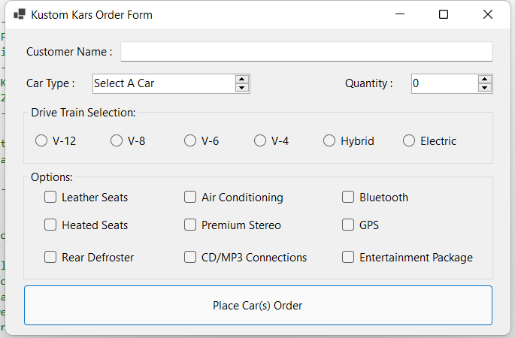Upon initial load.

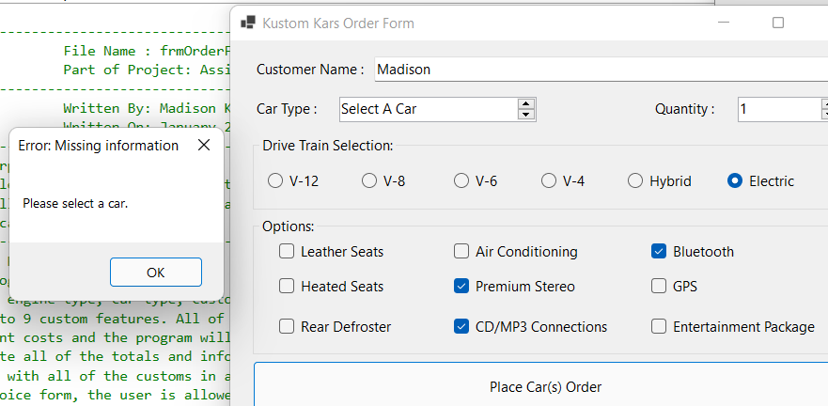If a value is not selected/added, an error message will pop up (all of the required sections have a similar error message.

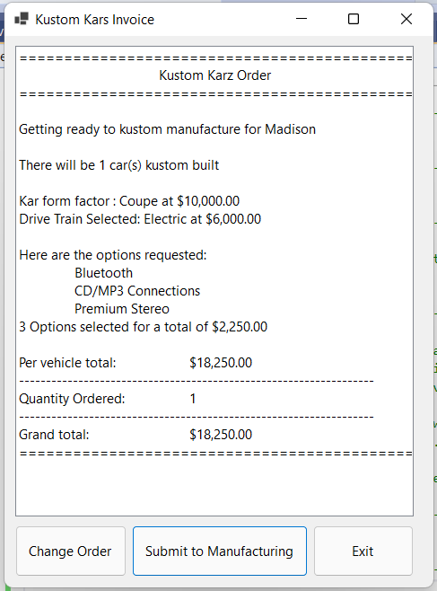

After filling out all required data

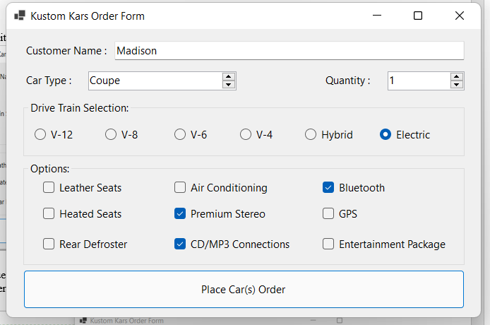Hitting the change order button on the invoice brings the user back to the order screen with ability to add or remove selections

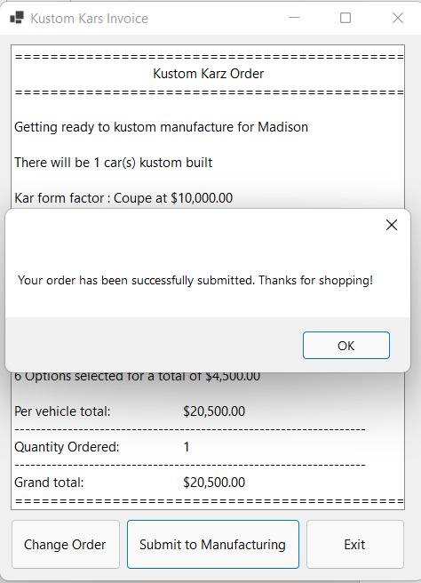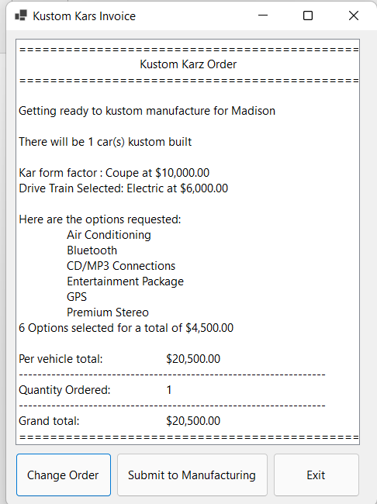after adding some features, I re clicked the Place order button. As you can see all totals are updated, and the new invoice screen is shown.

after clicking the submit to manufacturing button (right picture and bottom picture) show message and clear out previous options

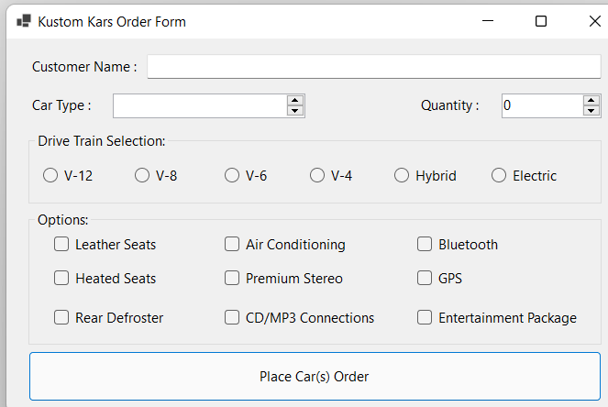

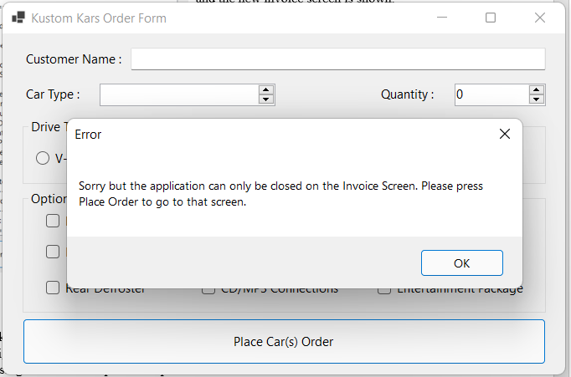

Trying to exit the order screen

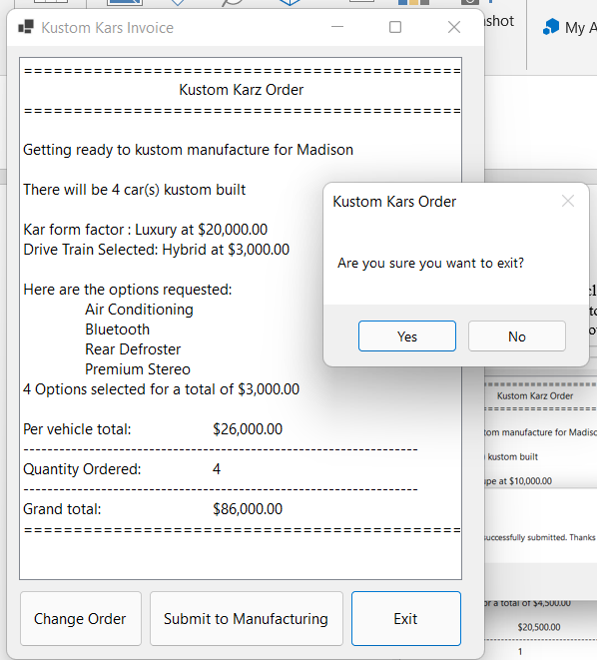

Hit the exit button on the invoice screen. I hit yes and it closed the program. The same happens when clicking the red X.